**Planning and Assessment** IRF20/3781

Gateway determination report

|  |  |
| --- | --- |
| **LGA** | Kiama |
| **PPA** | Kiama Municipal Council |
| **NAME** | Lot 442 Henry Parkes Drive (39 dwellings) |
| **NUMBER** | PP_2020_KIAMA_002_00 |
| **LEP TO BE AMENDED** | Kiama Local Environmental Plan 2011 |
| **ADDRESS** | Henry Parkes Drive, Jamberoo |
| **DESCRIPTION** | Lot 442 DP 1201831 |
| **RECEIVED** | 30 July 2020 |
| **FILE NO.** | IRF20/3781 |
| **POLITICAL DONATIONS** | There are no donations or gifts to disclose and a political donation disclosure is not required. |
| **LOBBYIST CODE OF CONDUCT** | There have been no meetings or communications with registered lobbyists with respect to this proposal. |

**1. INTRODUCTION**

**1.1 Description of planning proposal**

The proposal seeks to amend the Kiama Local Environmental Plan 2011 (Kiama LEP) to rezone the subject site and amend development standards to enable low density residential development of approximately 39 dwellings and environmental protection.

The site was identified for urban expansion in the Kiama Urban Strategy 2011 to help meet the housing needs of the Kiama community.

**1.2 Site and surrounding area**

The subject site comprises Lot 442 DP 1201831 Henry Parkes Drive, Jamberoo in the Kiama local government area.

Although the site is in the Jamberoo suburb catchment, it is located at the end of Henry Parkes Drive adjoining the north-western extent of the existing Kiama Downs residential area. The site is also surrounded by:

* the Princes Highway to the west (with Jamberoo located further beyond); and
* Minnamurra River adjoining the site to the north.

The site is approximately 3.1ha in size, is largely cleared undeveloped land and slopes moderately from Henry Parkes Drive north-east towards the

Minnamurra River (**Figure 2**). The northern part of the site near the Minnamurra River is flood prone and a small portion of the site is mapped as bushfire prone land.

**1.3 Existing planning controls**

The site is zoned E2 Environmental Conservation under the Kiama LEP.

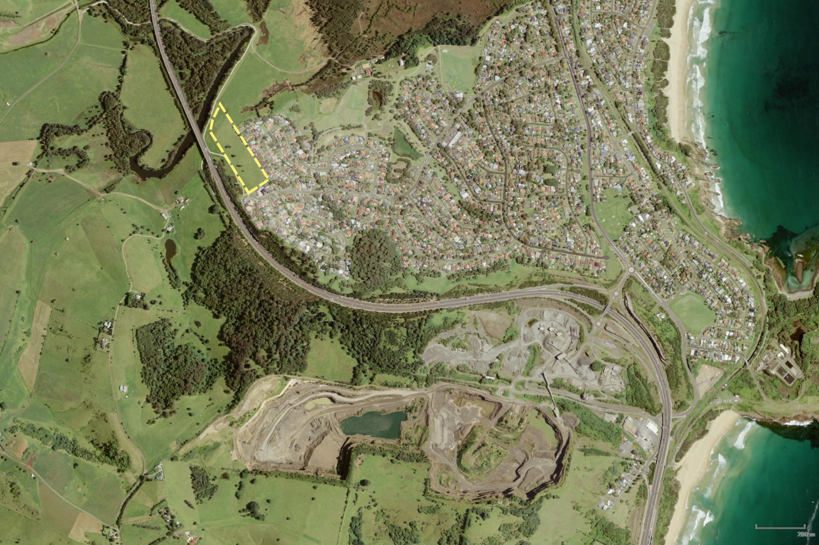

**Site**

**Minnamurra River**

**Princes Highway**

**Jamberoo**

**Kiama Downs**

**Bombo**

**Figure 1:** Site Context Map

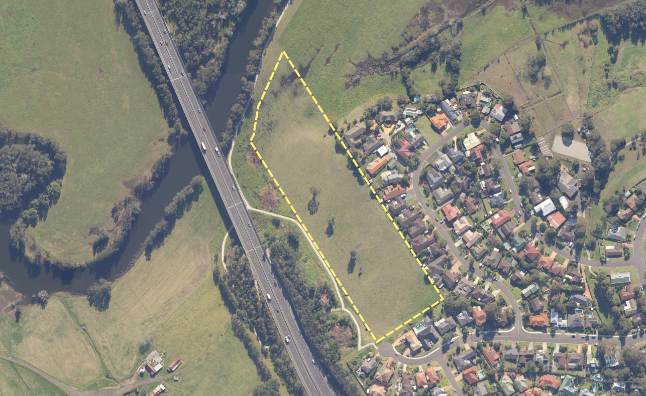

**Kiama Downs**

**Site**

**Minnamurra River**

**Princes**

**Highway**

**Figure 2:** Site Map

**2. PROPOSAL**

**2.1 Objectives or intended outcomes**

The objective of the proposal is to facilitate low density residential development of part of the site.

The objectives and intended outcomes outlined in the planning proposal are clear and adequate for exhibition purposes.

**2.2 Explanation of provisions**

To achieve the objectives of the planning proposal, it is proposed to make the following changes to Kiama LEP:

* rezone the subject land to:
  + part R2 Low Density Residential; and
  + part E2 Environmental Conservation.
* introduce a minimum lot size of 450m2 over the area proposed to be zoned R2 and 40ha over the area proposed to be zoned E2;
* introduce a maximum building height of 8.5m over the area to be zoned R2; and
* introduce a maximum floor space ratio of 0.45:1 over the area to be zoned R2.

The explanation of provisions in the planning proposal is clear and adequate for exhibition purposes.

**2.3 Mapping**

The planning proposal will require amendment to the relevant Land Zoning, Lot Size, Height of Buildings and Floor Space Ratio Maps in the Kiama LEP.

Draft maps are included in the planning proposal and considered adequate for public exhibition purposes.

**3. NEED FOR THE PLANNING PROPOSAL**

The proposal states it is needed to help assist in meeting the housing needs of the Kiama community in line with the Kiama Urban Strategy 2011 and housing projections contained within the Illawarra Shoalhaven Regional Plan.

The Department concurs the proposal is needed to meet the housing needs in Kiama consistent with local and regional strategic planning objectives. A planning proposal of this nature is considered the only way to achieve the intended outcomes.

**4. STRATEGIC ASSESSMENT**

**4.1 Illawarra Shoalhaven Regional Plan**

Key Directions of the Regional Plan relevant to the proposal include:

* Direction 2.1 – Provide sufficient housing supply to suit the changing demands of the region; and
* Direction 5.1 – Protect the region’s environmental values by focusing development in locations with the capacity to absorb development.

The Plan indicates that there is not enough land or market ready infill development in the planning pipeline to meet the projected demand of 2,850 new homes in Kiama up to 2036.

Action 2.1.1 of the Regional Plan commits the NSW Government to work with Kiama Council to monitor and review the potential of the area to accommodate housing demand.

Importantly, the site has been strategically identified for urban expansion in both the Kiama LSPS and the Kiama Urban Strategy as discussed in sections 4.2 and 4.3 of this report.

The proposal is consistent with the above identified Directions of the Regional Plan as it would:

* provide additional housing in Kiama to meet project demand;
* be located adjacent to the existing Kiama Downs township; and
* seeks to retain the E2 zoning of the northern part of the site (a riparian zone of the Minnamurra River considered to be of ecological significance).

**4.2 Kiama Local Strategic Planning Statement**

The Kiama LSPS provides a vision to guide land use planning decisions in Kiama over the next 20 years.

The subject site is identified for possible future urban expansion in the Kiama LSPS and associated greenfield opportunities maps (Map 1).

Planning Priority 1 commits Council to reviewing and investigating planning proposals submitted to Council for those greenfield dwelling opportunities identified in the town maps attached to this LSPS.

The proposal would deliver on the greenfield opportunity identified in the LSPS.

As above, the proposal also seeks to retain the E2 zoning of the northern part of the site which is of ecological significance and aligns with Theme 4 of the LSPS concerning protection of the environment.

It is noted that the planning proposal does not address consistency with the LSPS. A Gateway condition is therefore recommended requiring the planning proposal to be updated to address the LSPS prior to public exhibition.

**4.3 Kiama Urban Strategy**

The Kiama Urban Strategy 2011 was prepared by Kiama Council to inform the preparation of the Kiama LEP 2011.

The Strategy was not formally endorsed by the Department mainly on the grounds that it did not provide sufficient yields to meet the projected housing needs of Kiama.

Notwithstanding this, the Department supported the preparation of planning proposals for sites identified in the Strategy in order to contribute to housing supply in Kiama.

The site is identified for urban expansion in the Kiama Urban Strategy 2011 to help meet the housing needs of the Kiama community.

The Department understands the Strategy was recently repealed by Council noting potential future greenfield opportunities were carried over from the Strategy into the LSPS and Council has committed to preparing a new Local Housing Strategy over the short to medium-term.

**4.4 Kiama Community Strategic Plan**

The Kiama Community Strategic Plan (CSP) provides a long-term, community driven strategy for the future of Kiama and identifies priorities for healthy, well planned and managed places and environments, a diverse and thriving economy and responsible civic leadership in Kiama.

The planning proposal is considered consistent with priority 2.1 of the CSP to maintain the separation and distinct nature of local towns, villages and agricultural land. This is because it would provide planned and appropriate residential development, within the existing town boundaries and consistent with the Kiama Urban Strategy.

**4.4 Section 9.1 Ministerial Directions**

Relevant Section 9.1 Directions have been identified in the planning proposal.

Key applicable Directions are discussed in detail below.

2.1 Environmental Protection Zones

The objective of this Direction is to protect and conserve environmentally sensitive areas. The planning proposal seeks to rezone part of the site from E2 to R2 and is potentially inconsistent with this Direction.

However, the proposal is supported by a Flora and Fauna Assessment which found the subject site is a cleared paddock that is dominated by exotic pasture grasses and weeds. The northern riparian part of the site adjacent the Minnamurra River would retain its E2 zoning and associated protections. The assessment concluded that provided mitigation measures are in place, a future residential subdivision would be

unlikely to significantly impact threatened species or communities.

The proposal is also in accordance with the relevant Regional Plan, is justified by the Kiama Urban Strategy and Kiama LSPS.

The Secretary’s delegate may therefore be satisfied any potential inconsistency with this Direction has been justified in accordance with the terms of the Direction.

2.2 Coastal Management

The objective of this Direction is to protect and manage coastal areas of NSW.

The site is within the coastal zone as identified in State Environmental Planning Policy (Coastal Management) 2018 and the Direction therefore applies.

Specifically, the site is located wholly within the Coastal Environment Area Map of the SEPP and the northern part of the site is identified as ‘proximity area for coastal wetlands’ on the Coastal Wetlands and Littoral Rainforests Area Map.

Despite this, the proposal is supported by an Integrated Water Cycle Management Study which models potential water sensitive urban design measures aimed at ensuring residential development would not negatively impact on water quality, coastal wetlands and the coastal ecological environment. Impacts to the coastal area, including coastal wetlands, would be further assessed in detail at the development application stage.

The proposal is also in accordance with the relevant Regional Plan, is justified by the Kiama Urban Strategy and Kiama LSPS.

The Secretary’s delegate may therefore be satisfied any potential inconsistency with this Direction has been justified in accordance with the terms of the Direction.

2.3 Heritage Conservation

This Direction seeks to conserve items, areas, objects and places of environmental heritage significance and indigenous heritage significance.

The site does not contain known items of items, areas, objects or places of Aboriginal cultural heritage significance or environmental heritage significance.

An Aboriginal Cultural Heritage Due Diligence Assessment (ACHDDA) was undertaken to support the proposal which found a small area within the centre of the site has a moderate chance of Aboriginal cultural heritage being found in this location.

The ACHDDA recommends an Aboriginal Cultural Heritage Assessment be undertaken over the study area, prior to any ground disturbance. Should the assessment identify Aboriginal objects, an Aboriginal Heritage Impact Permit would be required prior to any impacts occurring.

The application is also supported by a Preliminary Historical Heritage Assessment which found that the drystone wall located along the eastern boundary of the study area contains technological research potential for demonstrating engineering and construction techniques of dry-stone walls built in the Kiama district.

The planning proposal states that the dry-stone wall will be retained as part of the residential subdivision, and a Statement of Heritage Impact will be prepared as part of the subsequent development application to assess potential impacts to the dry-stone wall.

The potential heritage significance of the site has been thoroughly considered, would be conserved by existing policy/legislation and is able to be managed through the development assessment process.

The Secretary’s delegate may be satisfied that any potential inconsistency with this Direction has been justified.

Consultation with Department of Premier and Cabinet (Heritage) is recommended to ensure potential heritage impacts are further considered prior to finalisation.

2.6 Remediation of Contaminated Land

The proposal is supported by a Preliminary Site Investigation (PSI) which made the following key conclusions:

* based on site history records, the site has remained undeveloped for an extended period;
* the condition of the site was consistent with documented history of land use and no areas of environmental concern were identified during site inspections; and
* no evidence of a former Underground Petroleum Storage System (UPSS) was identified through the review of available records and during a site inspection.

Based on the results of historical information and a site inspection, the PSI found the site may be considered suitable for the proposed sub-division and residential land use.

The Secretary’s delegate may be satisfied contamination issues have been appropriately considered and the proposal is consistent with the terms of this Direction.

Consultation with the Department’s Environment, Energy and Science Division is recommended to ensure potential contamination impacts are further considered prior to finalisation.

Contamination issues would also be further assessed in detail at the development application stage.

4.1 Acid Sulfate Soils

The objective of this Direction is to avoid significant adverse environmental impacts from the use of land that has a probability of containing acid sulfate soils.

The site is mapped as containing potential Class 3 and Class 5 acid sulfate soils (ASS).

The planning proposal is supported by a PSI which assessed the potential for ASS across the site. The PGA found the proposed development area would be limited to the Class 5 Area with minimal (if any) earthworks occurring in the Class 3 area. ASS is not typically found in Class 5 areas.

The PSI proposes that an Acid Sulphate Soil Investigation (sampling) and/or Management Plan be prepared as part of any future development application should works be required in the Class 3 area.

Based on the above, it is considered unlikely the proposal would cause significant adverse environmental impacts from ASS disturbance.

The Secretary’s delegate may be satisfied that any potential inconsistency with this Direction has been justified.

Consultation with the Department’s Environment, Energy and Science Division is recommended to ensure potential ASS impacts are further considered prior to finalisation.

4.3 Flood Prone Land

The northern part of the site is within the Flood Planning Area.

The planning proposal is supported by an Integrated Water Cycle Management Study which found the proposed extent of the R2 zoned land is principally outside the pre-development Flood Planning Area.

A minor area of filling is required in the northern corner of the proposed R2 zoned land to ensure it is outside of the 1% AEP flood extent (post-development). The minor filling is unlikely to have material influence on flood behaviour in the Minnamurra River. Flooding issues would be further addressed in detail at the development application stage.

Given the above, the Secretary’s delegate may be satisfied any potential inconsistency with this Direction is of minor significance.

Consultation with the Department’s Environment, Energy and Science Division is recommended to ensure potential flooding issues are further considered prior to finalisation.

4.4 Planning for Bushfire Protection

The very northern part of the site is mapped as bushfire prone land.

The proposal is supported by a Bushfire Assessment Report which found the proposal can satisfy the requirements of *Planning for Bush Protection 2006* (asset protection zones, roads widths and design, water supply etc). Detailed design and compliance with these guidelines would be assessed at the development application stage.

Consultation has not occurred with the NSW Rural Fire Service (NSW RFS) and consistency with Direction 4.4 remains unresolved.

A Gateway condition has therefore been recommended requiring consultation with the NSW RFS prior to exhibition.

**4.5 State environmental planning policies (SEPPs)**

Relevant SEPPs have been identified in Appendix A of the planning proposal.

The planning proposal is not inconsistent with relevant SEPPs.

SEPP 55 – Remediation of Land

Potential contamination issues to ensure consistency with SEPP 55 are addressed in Section 4.4 of this report.

SEPP – Coastal Management

Potential coastal management issues to ensure consistency with this SEPP are addressed in Section 4.4 of this report.

**5. SITE-SPECIFIC ASSESSMENT**

**5.1 Social and Economic**

The planning proposal found the rezoning would result in positive social and environmental impacts by providing additional residential zoned land within the existing town boundaries which would help meet the housing needs of the Kiama community.

**5.2 Environmental**

The majority the key potential environmental impacts of the proposal (ecological, coastal management, heritage, flooding, contamination, bushfire risk etc) have been addressed in Section 4.4. of this report.

The proposal is also supported by a Traffic Impact Assessment which found that traffic from the proposed development can be satisfactorily accommodated within the existing road network and the future road hierarchy adopted for the area.

In terms of site stability, the Preliminary Geotechnical Assessment provided with the planning proposal found the site has a low risk of slope movement and is suitable for

residential development.

Detailed design issues would be assessed at the development application stage.

**5.3 Infrastructure**

The planning proposal found there is adequate public infrastructure (water, sewer, electricity, telecommunications and traffic) available to support the proposed residential development.

Water, sewer and electricity servicing are likely to be provided by extension/augmentation of existing infrastructure in the vicinity of the site.

The applicant has contacted relevant service providers and Council is proposing agency consultation with key providers such as Sydney Water and Endeavour Energy.

**6. CONSULTATION**

**6.1 Community**

Council has proposed a 28-day exhibition period, which is appropriate considering the nature of the proposal.

**6.2 Agencies**

Council has proposed to consult with:

* the NSW RFS;
* the Department’s Environment, Energy and Science Division;
* Sydney Water;
* Department of Premier and Cabinet (Heritage); and
* Endeavour Energy.

The agency consultation proposed is considered appropriate and a Gateway condition has been recommended accordingly.

**7. TIME FRAME**

Council anticipates a 4 to 5-month time frame to finalise the LEP. It is recommended that a 12-month period be provided to enable a buffer in case issues arise during consultation or any other part of the process.

**8. LOCAL PLAN-MAKING AUTHORITY**

Council has asked for plan-making authority in relation to this proposal. This is considered appropriate, as the proposal is of local significance and is consistent with local and regional strategic planning.

**9. CONCLUSION**

It is recommended that the planning proposal is supported to proceed with conditions as it would facilitate additional housing to meet community needs in Kiama consistent with local and strategic planning objectives.

**10. RECOMMENDATION**

It is recommended that the delegate of the Secretary:

1. agree that any inconsistencies with section 9.1 Direction 2.1 Environmental Protection Zones, Direction 2.2 Coastal Management, Direction 2.3 Heritage Conservation, Direction 4.1 Acid Sulfate Soils and Direction 4.3 Flood Prone Land are minor or justified; and
2. note that the consistency with section 9.1 Direction 4.4 Planning for Bushfire Protection is unresolved and will require justification.

It is recommended that the delegate of the Minister determine that the planning proposal should proceed subject to the following conditions:

1. The planning proposal should be made available for community consultation for a minimum of 28 days.
2. Consultation is required with the following public authorities:
   * the NSW RFS;
   * the Department’s Environment, Energy and Science Division;
   * Sydney Water;
   * Department of Premier and Cabinet (Heritage); and
   * Endeavour Energy.
3. The time frame for completing the LEP is to be 12 months from the date of the Gateway determination.
4. Given the nature of the planning proposal, Council should be the local plan-making authority.
5. Prior to public exhibition, the planning proposal shall be updated to address:
6. Kiama Local Strategic Planning Statement; and
7. section 9.1 Direction 2.6 - Remediation of Contaminated Land.

25/08/2020

**Graham Towers**

**A/Director, Southern Region**

**Local and Regional Planning**

Assessment officer: Andrew Hartcher

Senior Planner, Southern Region

Phone: 4247 1823

Attachments

Attachment A – Planning Proposal and Appendices

Attachment B – Gateway Determination

Attachment C – Letter to Council